# Use case

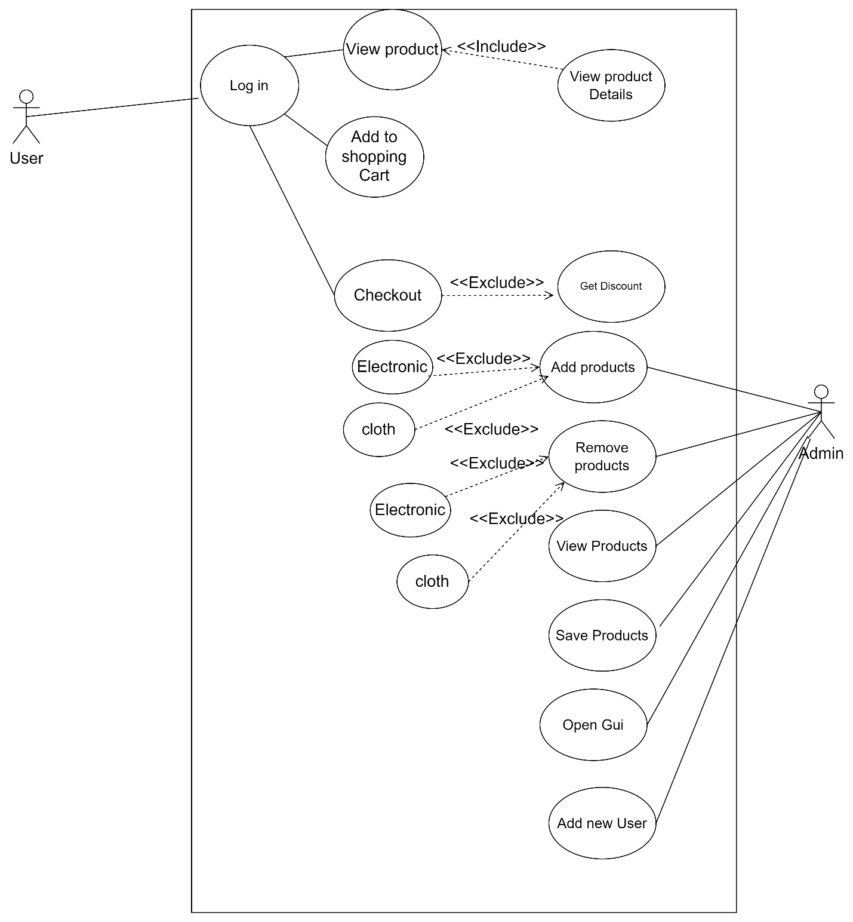

# Test Plan

|  |  |  |  |  |
| --- | --- | --- | --- | --- |
| Test | Input | Output | Expected output | Data Type |
| 1. validation | A,23a | enter a valid Integer input(returns the same question) | Error message and rerequest of user input | String |
| 1. validation | 21 | enter a valid Integer input | Error message and request of user input | Integer |
| 1. user | 1 | New user question | Request for new user details | int |
|  | Y | New user created | Create new user | String |
|  | N | Pops login gui | Pop login gui | String |
|  | A21,21 | Error message, returns to main login | Error message and returns input | String, integer |
| 1. Manager | 2 | Ask for password | Request validation | Integer |
|  | password | Show console menu | Direct to console menu | String |
|  | Wrong password | Password error,return to main | Show password incorrect | String |
|  | 1 | Add product menu | Direct to add product menu | Integer |
|  | 2 | Remove product | Direct to product list | Integer |
|  | 3 | Show all products | show all products | Integer |
|  | 4 | Save all products | Save the products to the file | Intger |
|  | 5 | Open GUI | Open GUI | Integer |
|  | 6 | Close the program | Exit the program | Integrer |
|  | 7 | Error message return menu | Error message and return menu | Intger |
|  | A | Error message return menu | Error message return menu | String |
| 1. Add products | A | Error message return add menu | Error message return add menu | String |
|  | 23 | Error message return add menu | Error message return add menu | Integer |
|  | 1 | Add electronic product | Add electronic product | Integer |
|  | 2 | Add cloth product | Add cloth product | Integer |
|  | 3 | Return to main menu | Return to main menu | Integer |
| 1. Remove product | Index number | Removes the product with the index number | Removes the product with the index number | Integer |
|  | A | Error message.return to main menu | Error message.return to main menu | String |